**RFC-LFP003**

**Suggested problem**  
Geolog wrapper for Herald’s code to determine sonic velocities in carbonates  
  
  
**Suggested solution**

Use modified RokDoc TensorFlow models in Geolog project LFP to estimatie carbonate sonic velocities in a two-step workflow: Calculate first the petrophysical rock type PRT via the LogLan program carbonate_regression_prt.lls – see Figure 1.

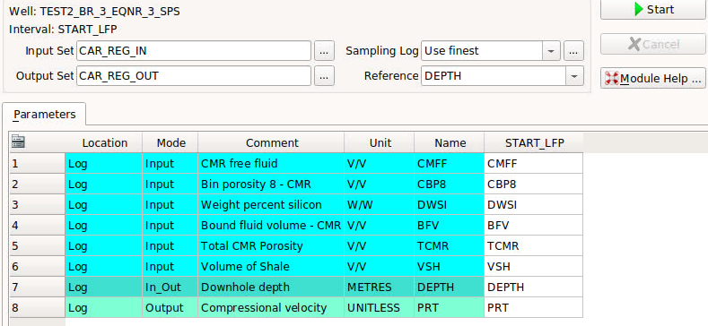  
Figure 1. Estimating petrophysical rock type by carbonate_regression_prt.lls.

The second step is to either use LithoScanner logs (Figure 2) or MultiMin logs (Figure 3) to determine the sonic compressional and shear logs.

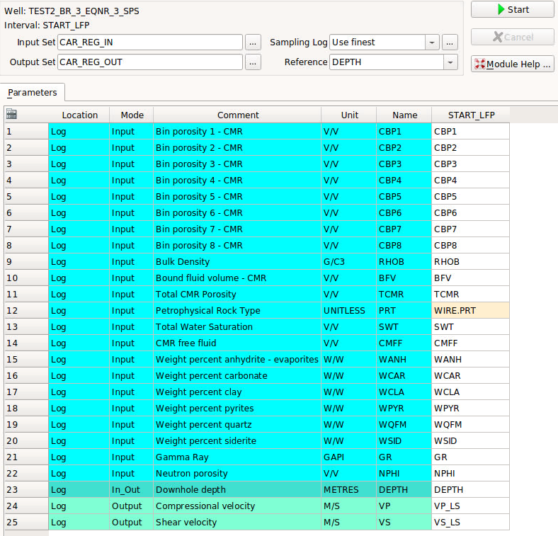  
Figure 2. Estimating sonic velocities for by carbonate_regression_ls.lls.

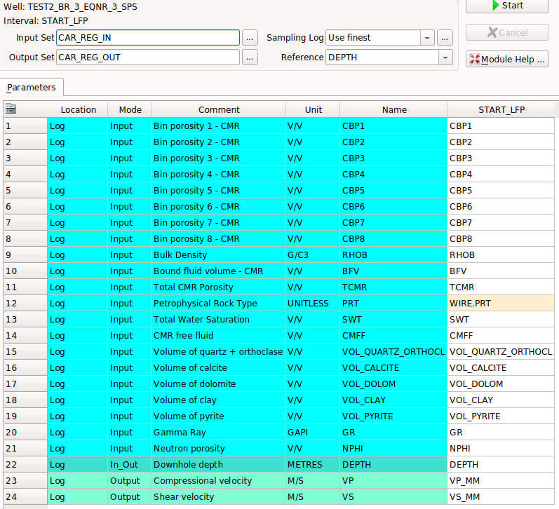  
Figure 3. Estimating sonic velocities for by carbonate_regression_mm.lls.

**Outline of Implementation - Wrapping of External Python Code to Geolog**

The current implementation was done with a pure Python wrapper file as shown in Figure 4. The location of config INI file (Figure 6) is at “loglan\external\rokdoc_carbonate_regression_models” (Figure 5) give the location to the TensorFlow models.  
  
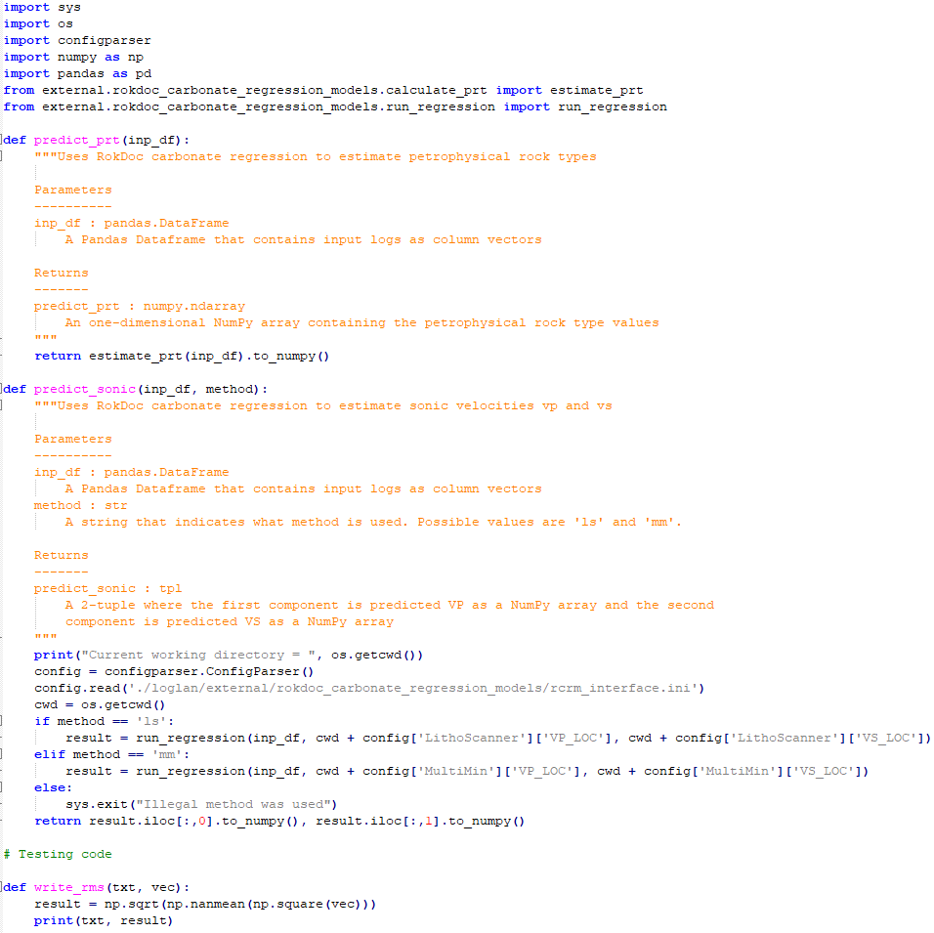  
Figure 4. Wrapper file rcrm_interface.py.

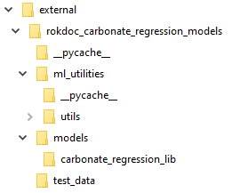  
Figure 5. Folder structure for external code.

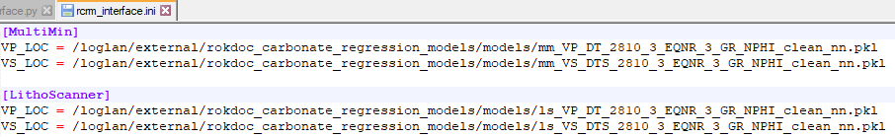  
Figure 6. INI file for pickle files.